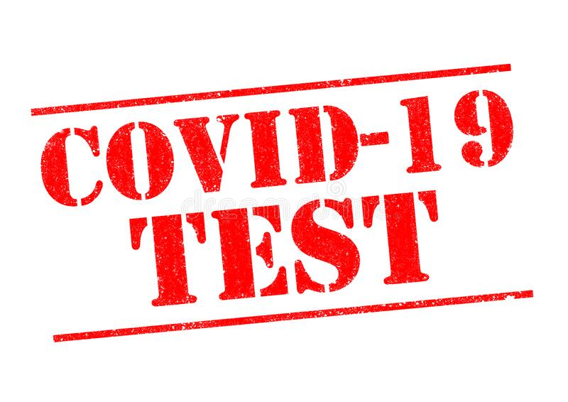
April 21, 2021
Lower Brule Community Center
11:30 a.m. to 4:30 p.m.

